Aspen Guide for Parents and Students

Accessing Aspen

To get to Aspen - Go to the Allegany County Public Schools homepage https://acpsmd.org. Click on the popular links button on the left hand side and a drop down menu will appear. Click on the Aspen button.

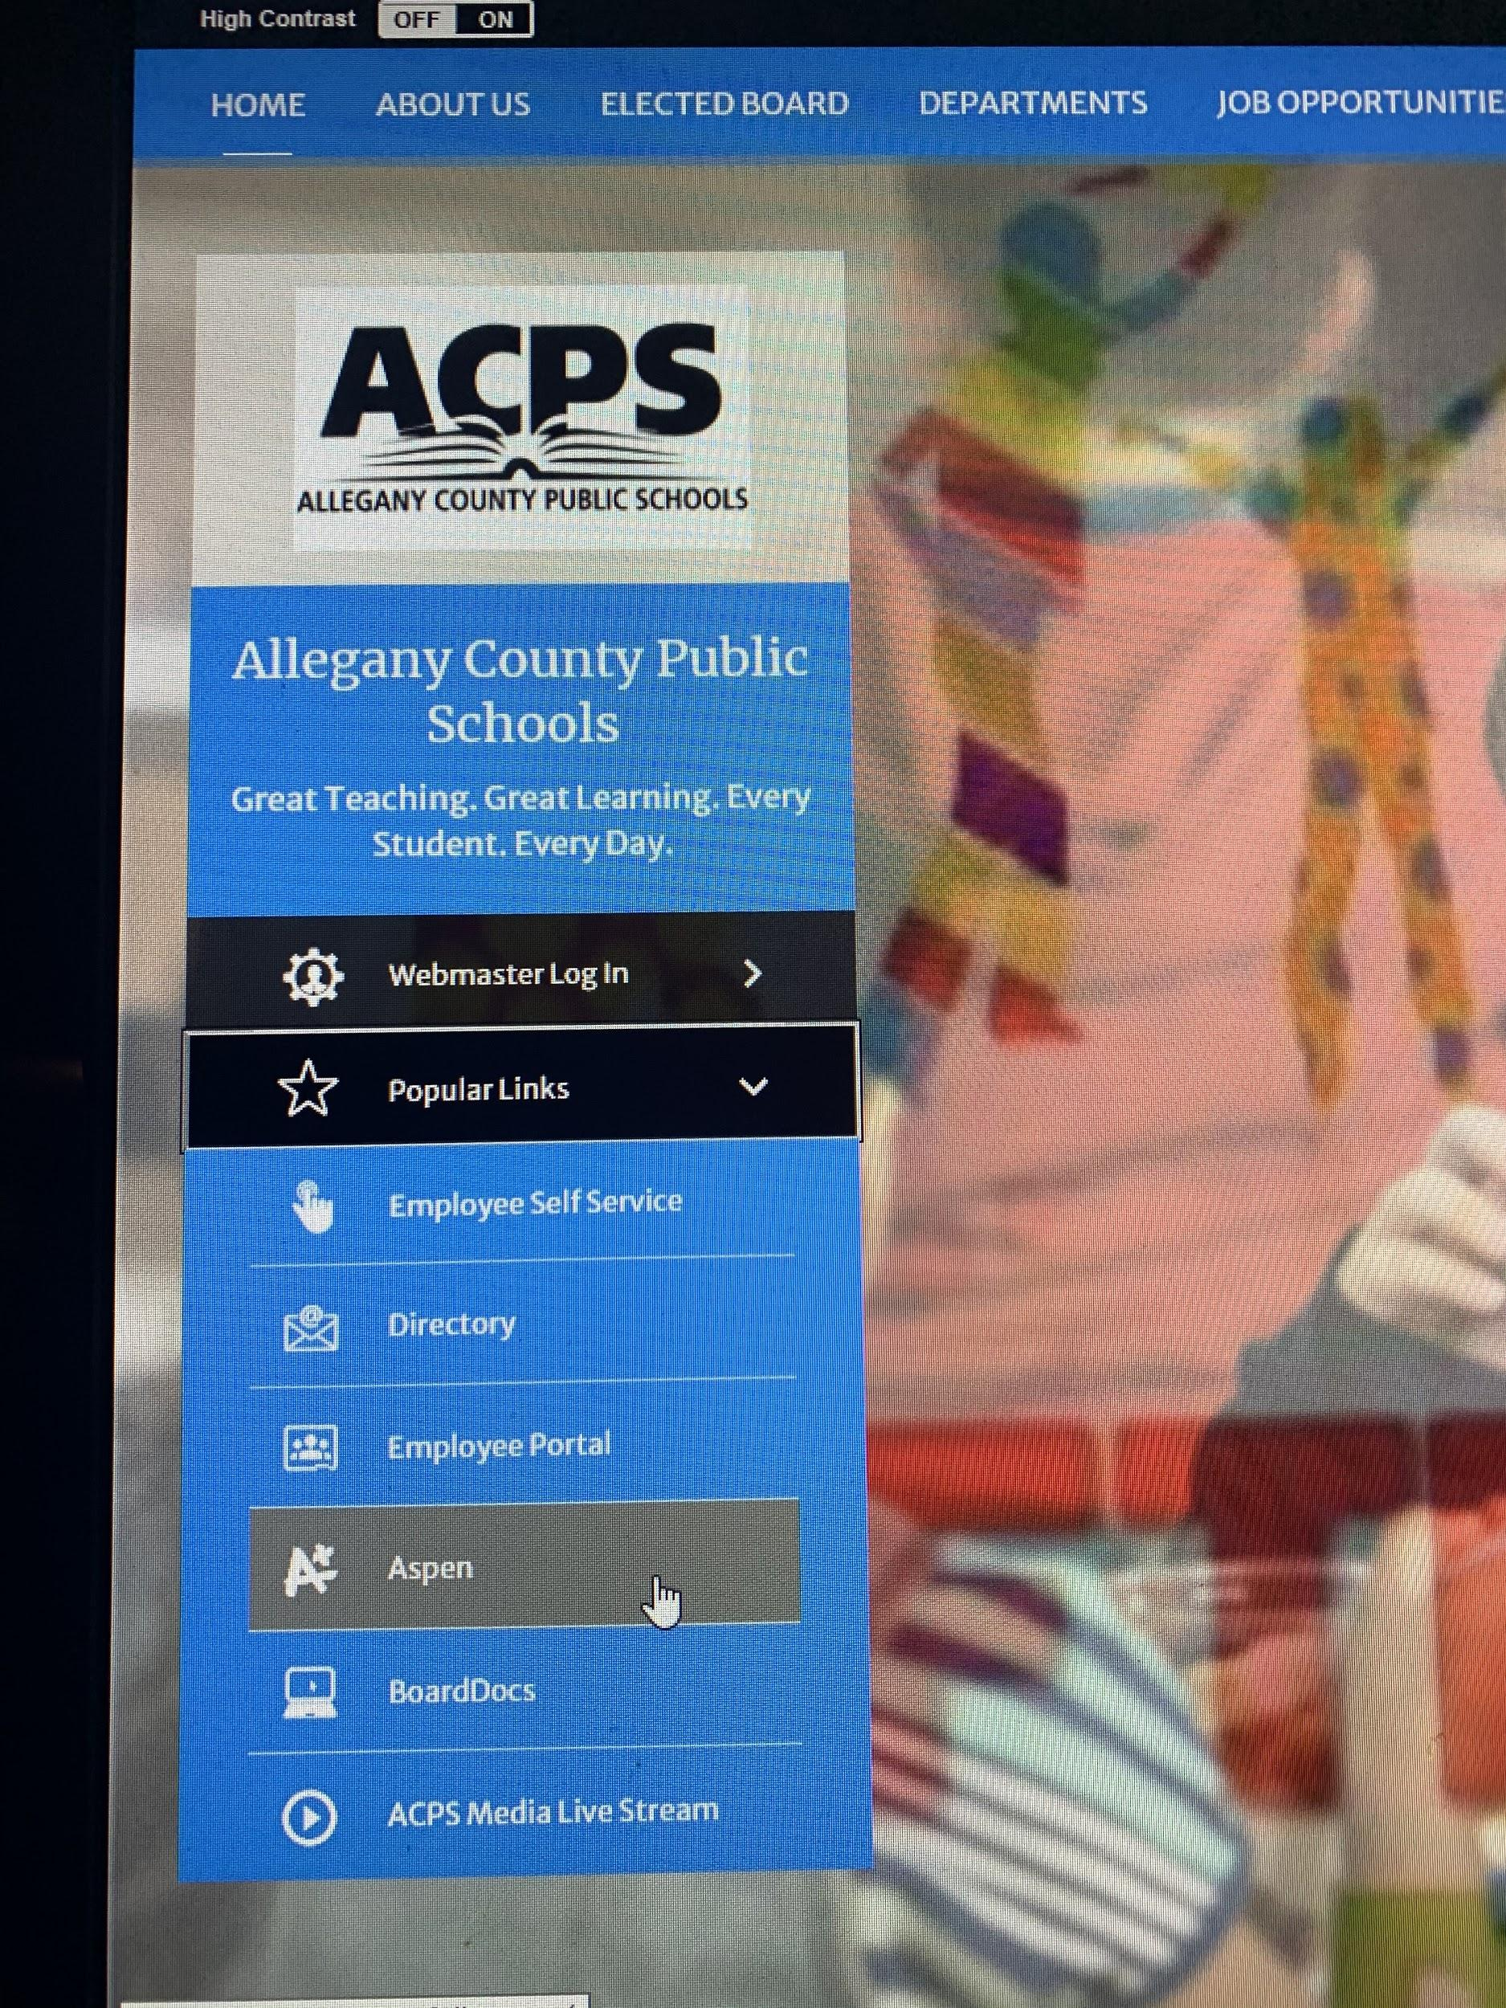

Login ID is the student’s lastname.firstname. Password is their 4 digit number (contact school if not known), Click Log On.

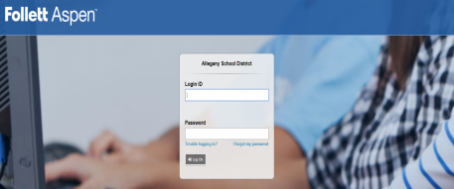(over)   
Navigating Aspen

The PAGES top tab may have important announcements. It also includes Recent Activity, a To Do list, Grades, and Published Reports.

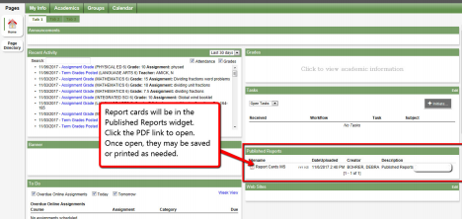

Published Reports: Report cards will appear under Published Reports. Other reports published here may include Assessment results.

NOTE: If you have your e-mail address updated in Aspen, you will receive an e-mail notifying you when reports are published. To update your e-mail address, in the upper right corner of the screen, click the student name, set Preferences, from the Security tab, you may update your Primary email then OK.

Recent Activity: Shows tests, assignments, etc.

Grades: Click on “Click to view academic information” will show current grades.

Tasks: Student Mass Notification Opt-In and Do Not Distribute (DND) information for student may be updated using the Initiate Button in the Tasks widget.

The My Info tab can be used to find student information including: transcripts, current schedule, contacts, attendance, and assessment scores.

The Academics tab can be used to see class attendance and grade information. Current class grades and information can also be accessed from the PAGES top tab by clicking the “Click to view academic information” section in the Grades widget.

The Calendar tab can be used to view completed and upcoming assignments.